# Exercise: Operating Systems

Problems for exercises and homework for the ["Software Technologies" course @ Software University.](https://softuni.bg/trainings/4383/software-technologies-january-2024)

## Working with Windows Task Manager

1. **Open Windows Task Manager:**
   * Press "Ctrl+Shift+Esc" on your keyboard or right-click the taskbar and select "Task Manager."

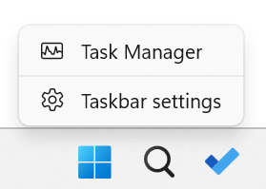

1. **View Processes:**
   * Click on the "Processes" tab to see a list of all running processes.

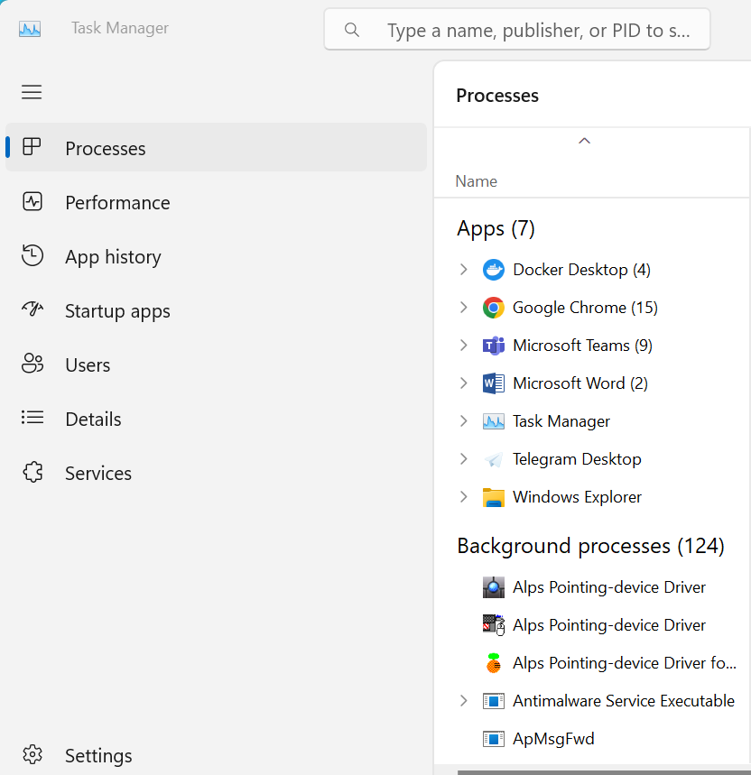

* + Identify some processes that are currently running on your system, and make a note of their names and the amount of CPU and RAM they are using.

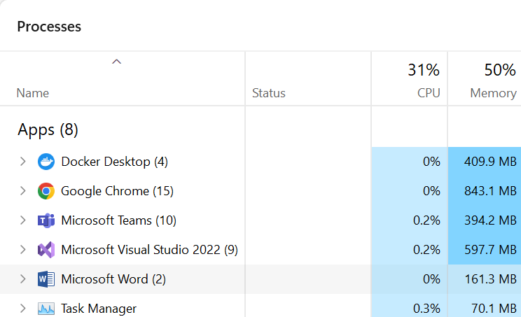

1. **Kill a Process:**
   * Select a process that you want to stop or close. Right-click on the process and select "End Task" or click on the "End Task" button at the corner of the Task Manager window.

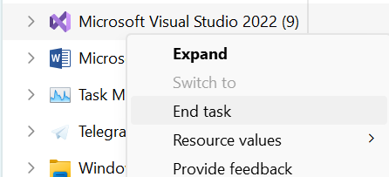

* + Confirm the action by clicking on "End Process" on the pop-up window.

1. **View CPU and RAM Usage:**
   * Switch to the "Performance" tab to see real-time graphs of your system's CPU, memory, disk, and network usage. Observe the graphs to see how your system's resources are being used.

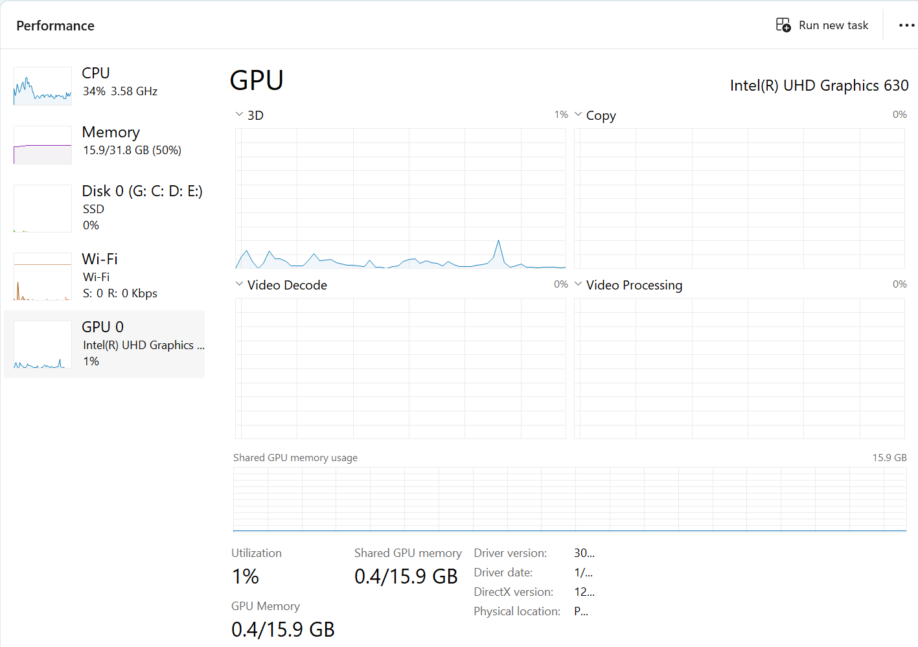

1. **Try the Details Tab:**
   * In the details tab, you will find more specific information about every single process.

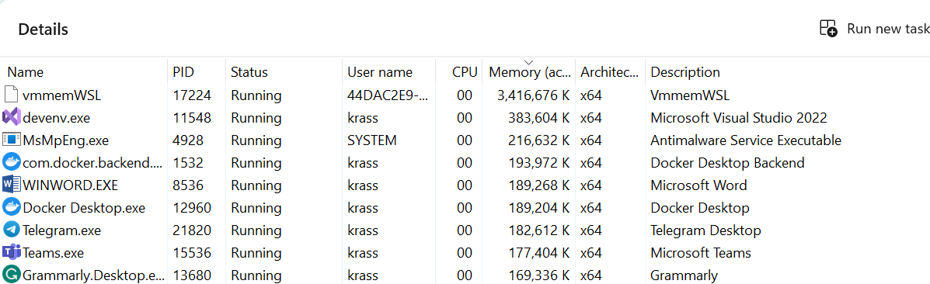

## Play with Windows Terminal

1. **Install Windows Terminal:** 
   * If you have not installed Windows Terminal, go to the Microsoft Store and download and install it.

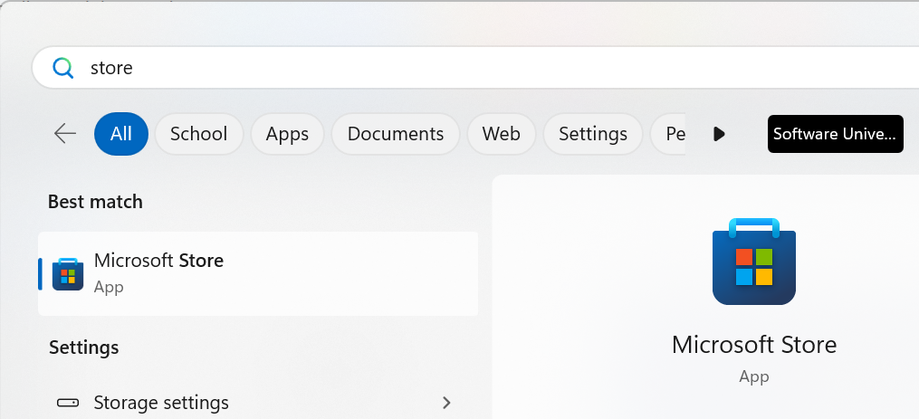

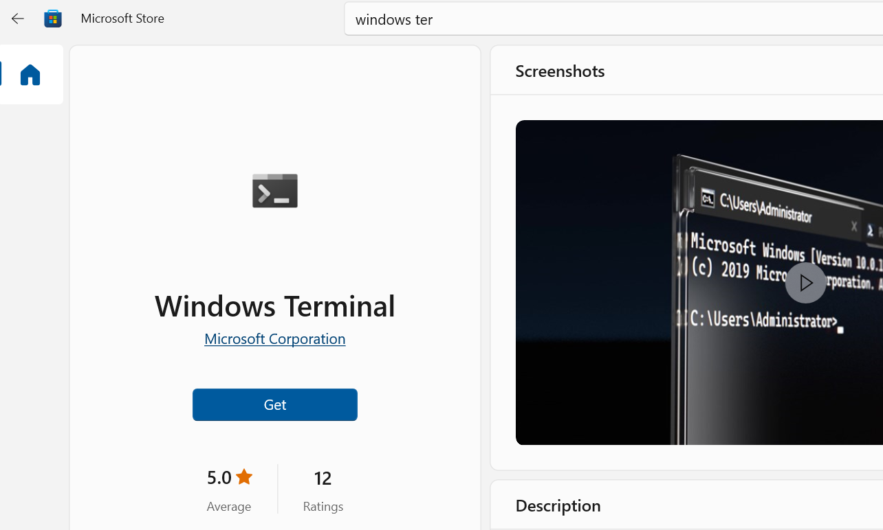

1. **Open Windows Terminal:** 
   * Open the Windows Terminal by searching for it in the Windows Start Menu.

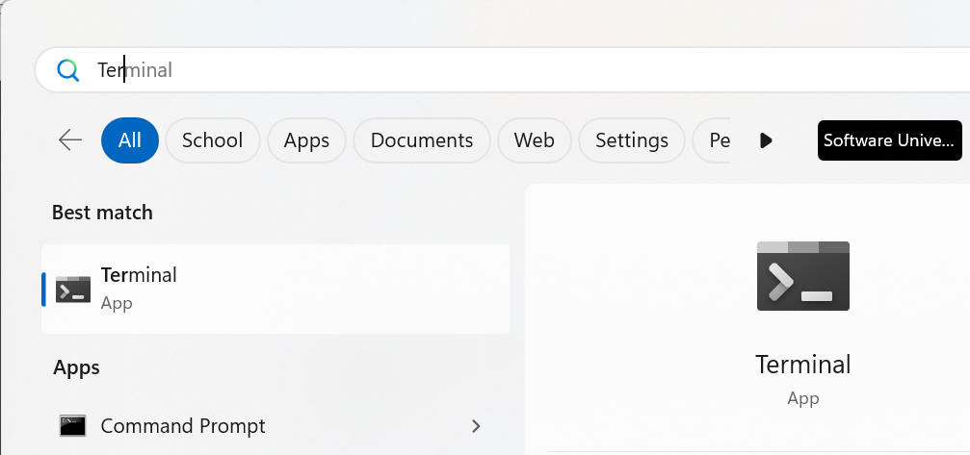

1. **Create a New Tab:**
   * Click on the "+" icon in the tab bar to create a new tab.

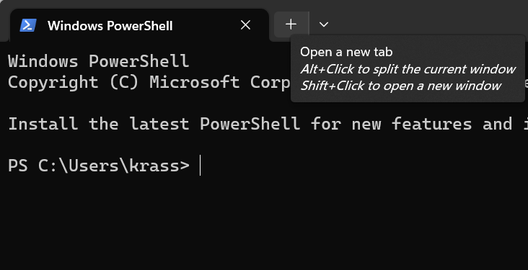

1. **Open Command Prompt:**
   * In the new tab, type "cmd" and press Enter to open the Command Prompt.

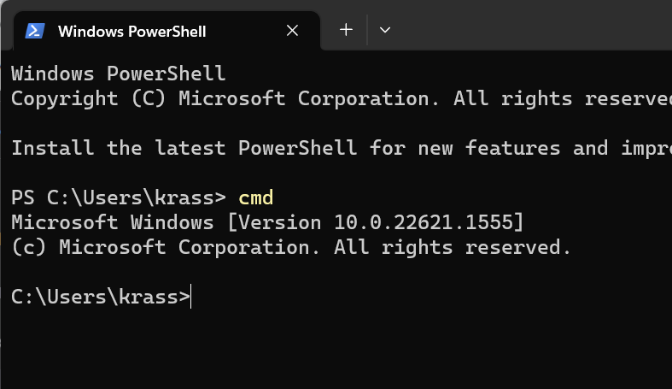

1. **Run a Command:**
   * Type "dir" in the Command Prompt and press Enter to display a list of files and folders in the current directory.

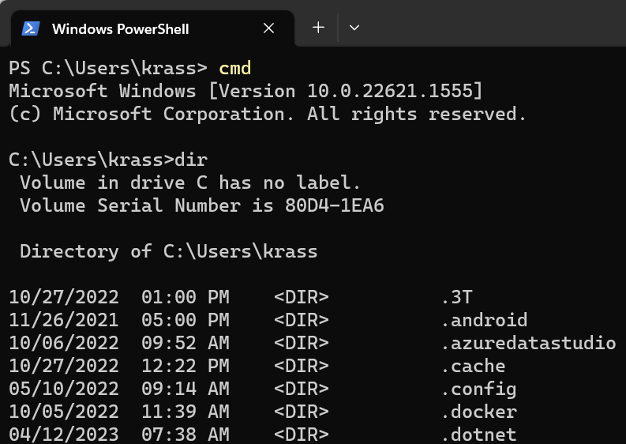

* + Type "cd" in the Command Prompt. This command changes the current directory. For example, "cd C:\Users\" will take you to the Users directory.

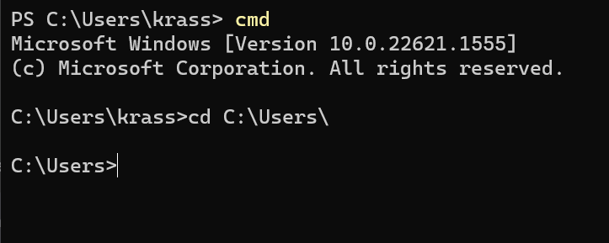

* + "mkdir": This command creates a new directory. For example, "mkdir My-Folder" will create a folder named "My-Folder" in the current directory.

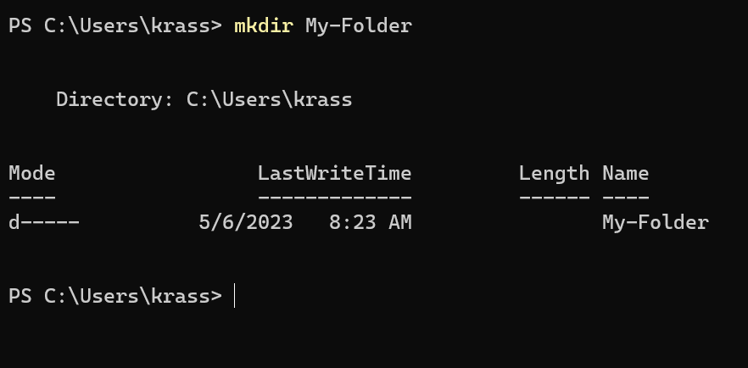

* + "echo": This command displays text on the console. For example, echo "Hello, World!" will display the text "Hello, World!" on the console.

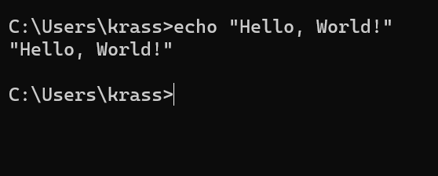

* + "ping": This command tests network connectivity by sending packets to a specified network host. For example, ping google.com will test the connectivity to the Google website.

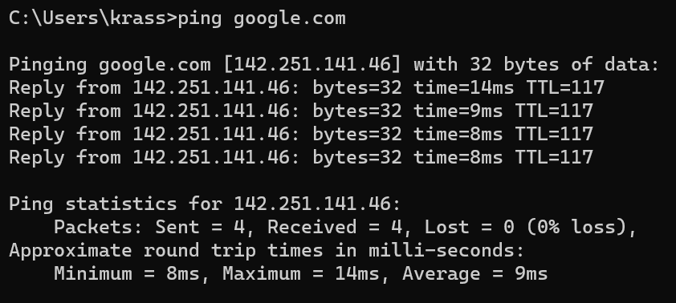

* + "ipconfig": This command displays the current IP configuration of your network adapters.

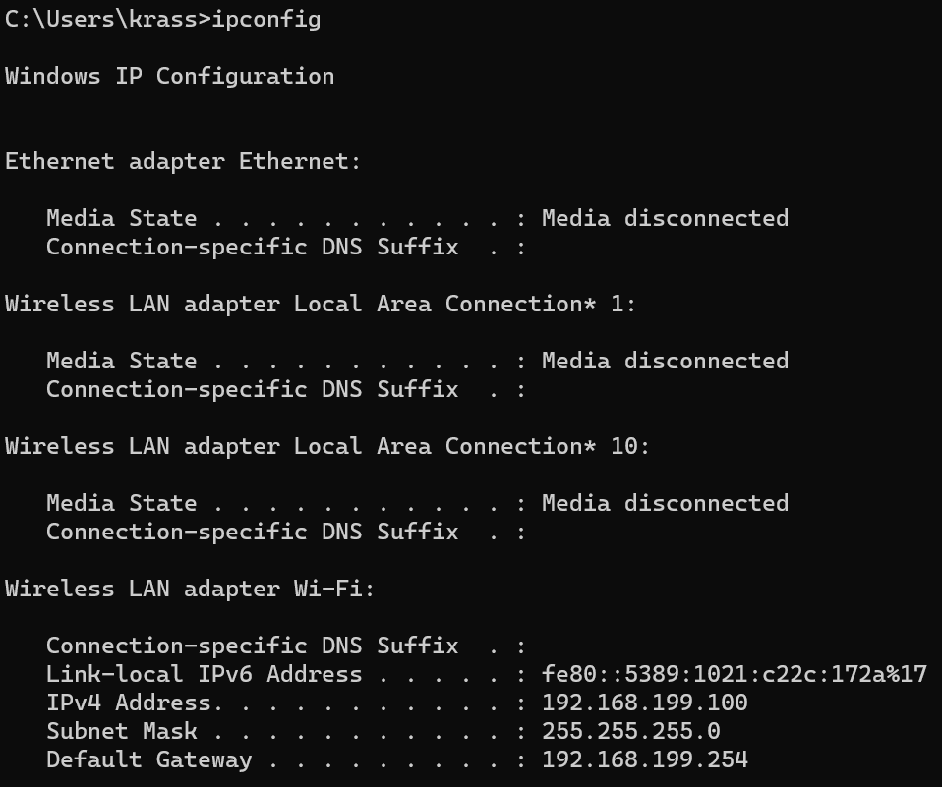

* + "tasklist": This command displays a list of running processes on your computer.

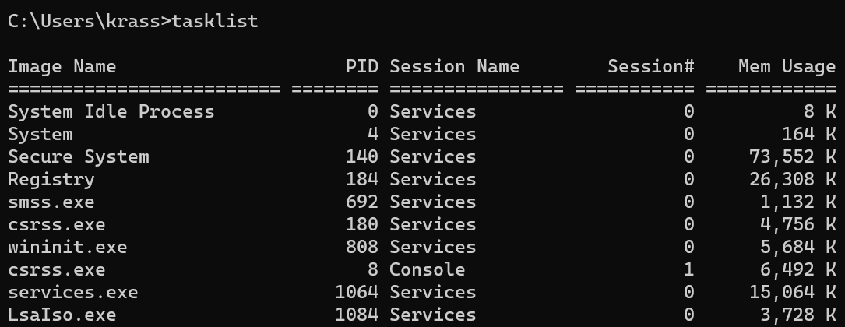

* + "taskkill": This command terminates a specified process. For example, "taskkill /im notepad.exe" will terminate the Notepad process.



* + "systeminfo": This command displays detailed system information about your computer.

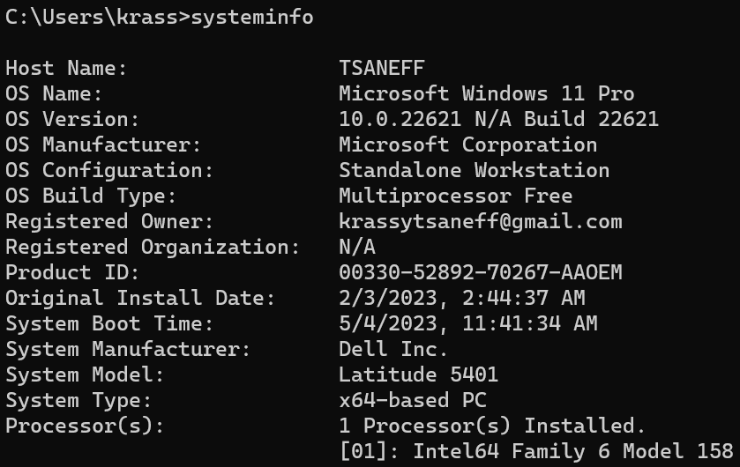

## Use Remote VM Instances: Docker Playground

1. **Docker Account:**
   * Go to the Docker Playground [website](https://labs.play-with-docker.com/) and sign up for an account if you haven't already.

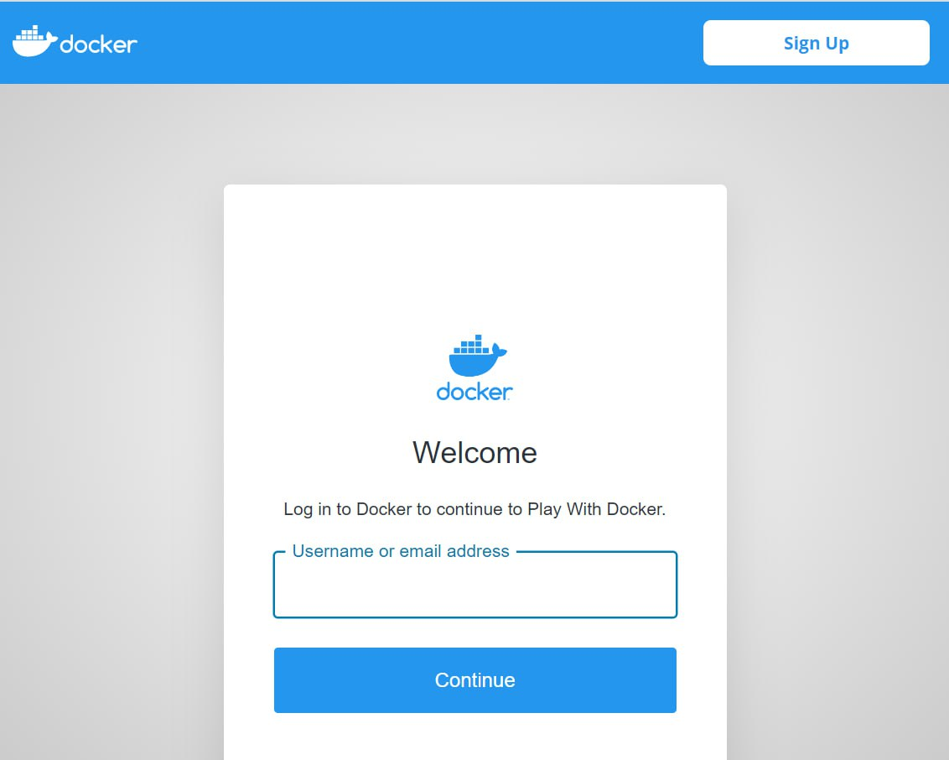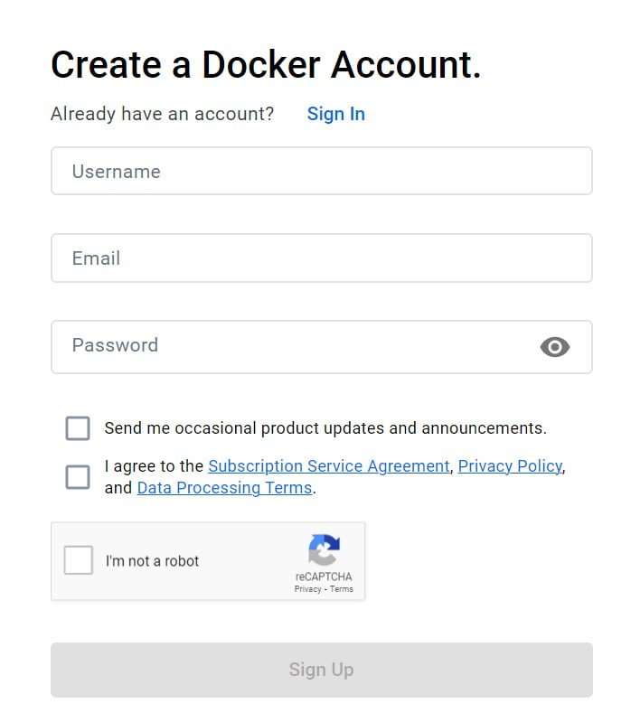

1. **New VM Instance:**
   * Once you're signed in, you'll see the Docker Playground dashboard. Click the "Add New Instance" button to get started.

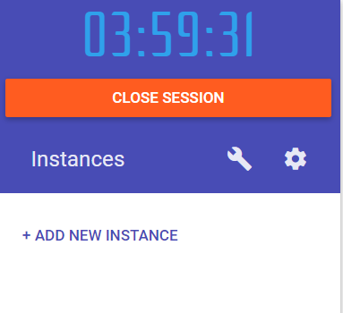

1. **Running a Container:**
   * You'll be presented with a terminal interface that allows you to run Docker commands. Try running the following command to download and run the "hello-world" container:

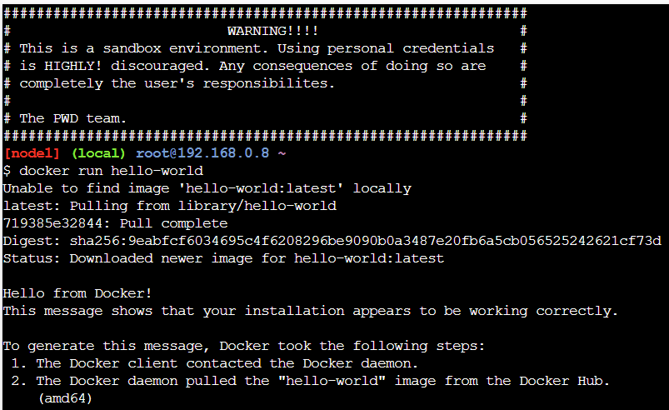

* + This command should download the "hello-world" container image from Docker Hub and run it on your local machine. You should see a message in the terminal confirming that the container ran successfully.
  + ***When an operator executes***"docker run"***, the container process that runs is isolated in that it has its own file system, its own networking, and its own isolated process tree separate from the host.***
  + **Use the "docker ps -a" command to list all running containers.**

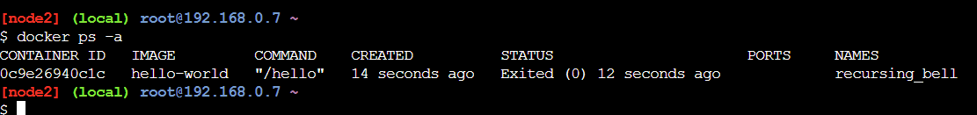

1. **Play with Docker - Now that you've run your first container, try running some other Docker commands to explore the features of Docker Playground:**
   * Start by creating a new environment in Docker Playground.
   * Once your environment is ready, use the "**docker run –d –p 8080:80 nginx**" command to create a new container using the **nginx image**:

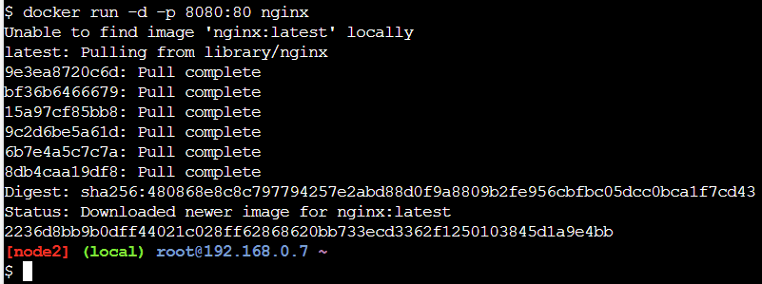

* + This command will download the **nginx image** from Docker Hub and create a new container running that image. The **-d** option tells Docker to run the container in detached mode, meaning it will run in the background. The **-p** option maps **port 8080** on your local machine to port 80 inside the container, allowing you to access the web server running inside the container.
  + Use the "**docker ps**" command to verify that the container is running:



* + To stop a running Docker container, you can use the "**docker stop**" command followed by the container ID or name. For example, to stop a container with the name "compassionate_allen", you can use the following command:

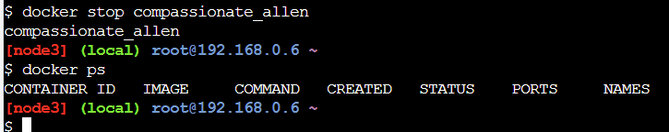

* + To list all running and stopped Docker containers on your system, you can use the "**docker ps -a**" command.



* + To remove a Docker container, you can use the "**docker rm**" command followed by the container ID or name. For example, to remove a container with the name "compassionate_allen", you can use the following command:

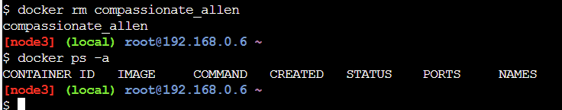

1. **Extract information on from JSON with** "**jq**" **command:**
   * The "**jq**" command is used to transform JSON data into a more readable format and print it to the standard output on Linux.
   * Start a new container with the bash shell by running the following command:



* + This command starts a new container with an interactive [**bash**](https://en.wikipedia.org/wiki/Bash_(Unix_shell)) shell.
  + Use the curl command to make an HTTP request to the Zippopotam.us API endpoint and pass the postal code as a parameter. For example, to get the location data for the postal code "1000", you can run:



* + This command makes an HTTP request to the API endpoint and pipes the response to the "**jq**" command, which extracts the JSON data from the response and prints it to the console.

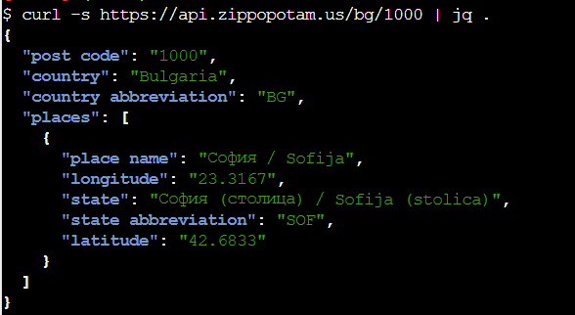

## Play with Linux Shell

1. **Install Windows Subsystem for Linux (WSL):** 
   * Open PowerShell or Windows Command Prompt in **administrator mode** by right-clicking and selecting "Run as administrator", enter the "**wsl --install**" command.

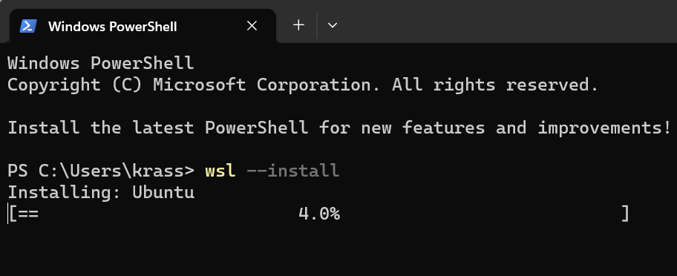

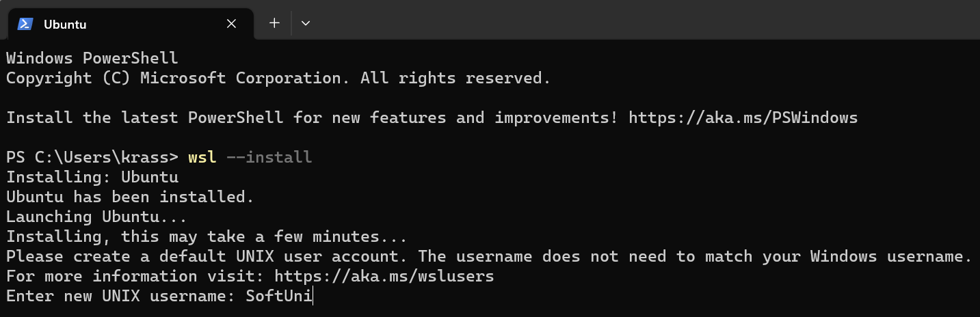

1. **Install a Linux distribution:** 
   * Once you have installed WSL, you need to install a Linux distribution of your choice.
   * You can choose from a variety of distributions available on the Microsoft Store, such as Ubuntu, Debian, Fedora, and more.
   * To install a Linux distribution, simply search for it on the Microsoft Store and install it like any other app.

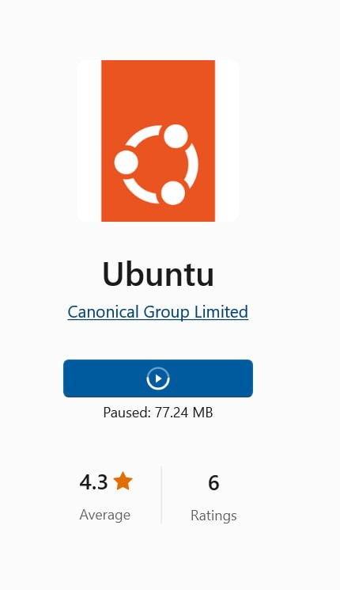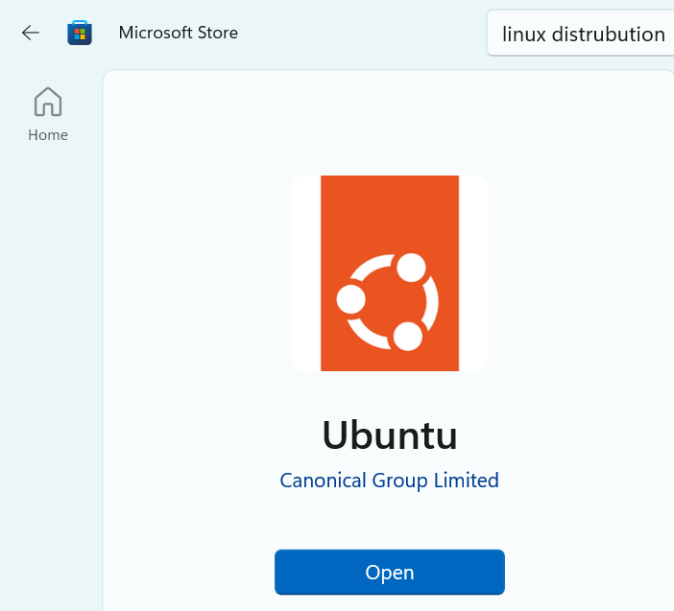

1. **Launch the Linux distribution:**
   * After installing the Linux distribution, you can launch it from the Start menu or by typing the distribution name in the Windows search bar.

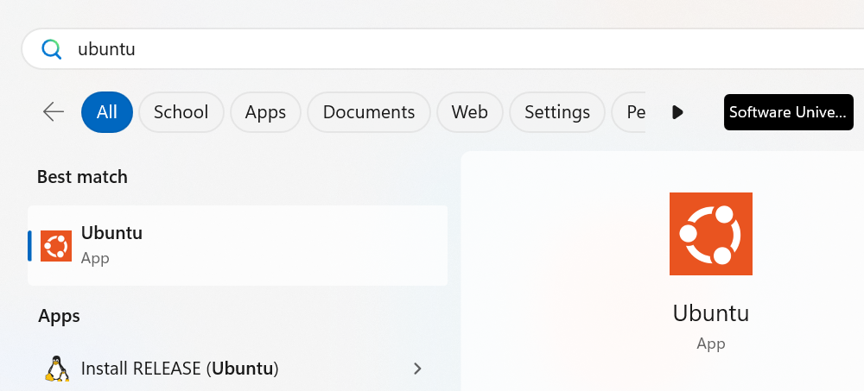

1. **Set up a user account:**
   * When you launch the Linux distribution for the first time, it will prompt you to set up a user account. Follow the instructions to set up a username and password.

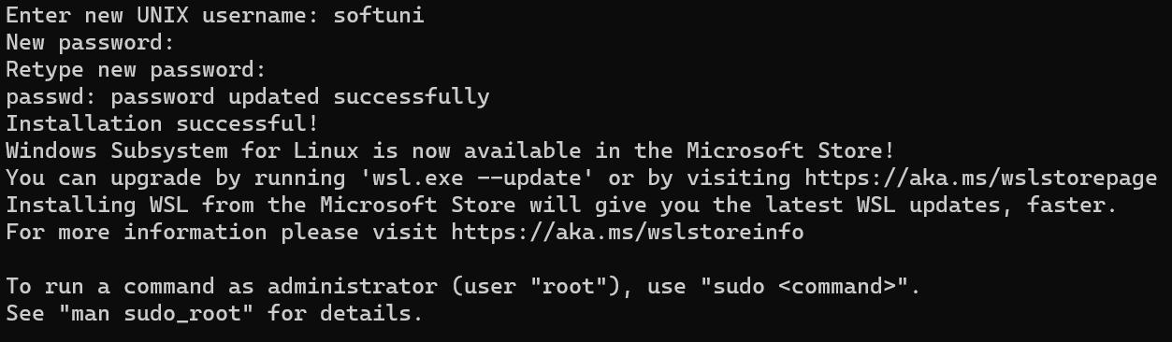

**Start using the Linux shell:**

* + Once you have set up a user account, you can start using the Linux shell by typing commands in the terminal.
  + The Linux shell is similar to the Windows Command Prompt, but with a different syntax.
  + You can use the Linux shell to navigate the file system, create and edit files, install packages, and run scripts.

1. **Familiarize yourself with basic Linux commands:**
   * Here are some basic Linux commands that you should know:
     + **ls**: List the contents of a directory
     + **cd**: Change the current directory
     + **mkdir**: Create a new directory

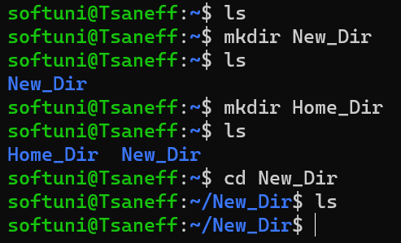

* + - **touch**: Create a new file

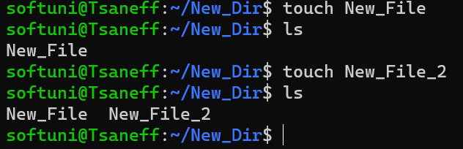

* + - **nano**: Open a file for editing

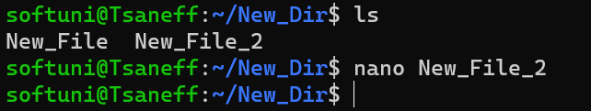

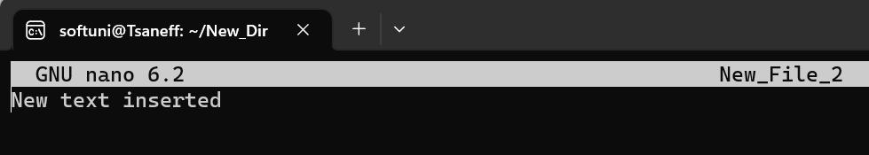

* + - sudo: Run a command with administrative privileges
    - apt-get: Install packages from the distribution's repository

**Work with Nano Editor:**

* + Navigate the Nano editor:
    - Once the Nano editor is open, you can use the arrow keys to navigate through the file. You can also use the page up and page down keys to move through the file more quickly.
  + Edit the file:
    - To edit the file, simply move the cursor to the location where you want to make a change and type in the new text.
    - You can also use the backspace key to delete text or the insert key to toggle between insert and overwrite modes.
  + Save the changes:
    - Once you have made the necessary changes, you need to save the file.
    - To do this, press the Ctrl and O keys simultaneously.
    - This will prompt you to confirm the filename and location where you want to save the file.
    - Once you have confirmed this information, press Enter to save the file.
  + Exit the Nano editor:
    - To exit the Nano editor, simply press the Ctrl and X keys simultaneously.
    - If you have made any changes to the file, you will be prompted to save them before exiting.

1. **Install additional packages:** 
   * Update the package list:
     + Before installing any software, it is always a good practice to update the package list.
     + Type the "**sudo apt-get update**" command in the terminal to update the package list:

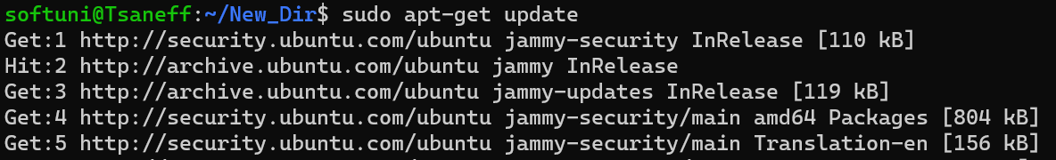

* + One of the advantages of using the Linux shell in a Windows environment is that you can install a wide variety of packages and tools that are not available on Windows.
  + To install additional packages, use the apt-get command followed by the package name.
  + For example, to install the Python programming language, you can run the command "**sudo apt-get install python2**".

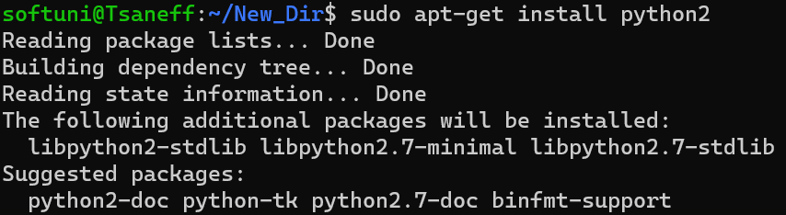

1. **Use the Linux shell with Windows files:**
   * Identify the drive letter and path of the Windows file:
     + The first step is to identify the drive letter and path of the Windows file that you want to access.

For example, if the file is located on the C: drive in a folder named "My_Folder", the path would be "C:\My_Folder".

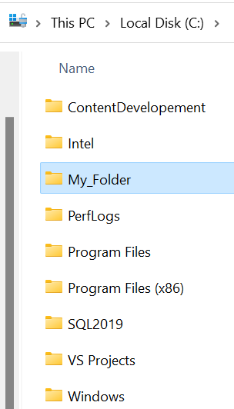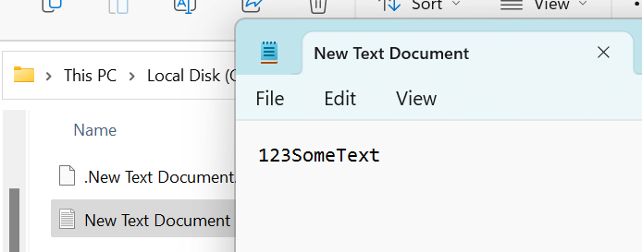

* + Mount the Windows drive:
    - Next, you need to mount the Windows drive using the "**mount**" command.
    - Type the following command in the terminal, replacing "**drive_letter**" with the drive letter of the Windows drive (e.g. C) and "path/to/windows/files" with the path to the folder containing the files you want to access:



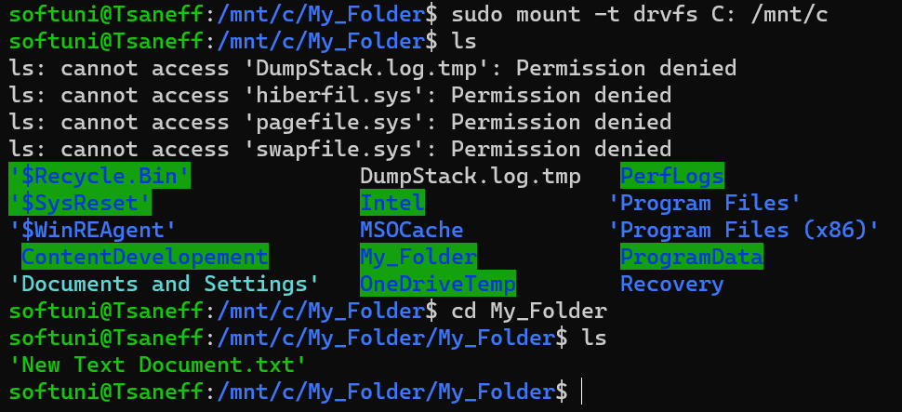



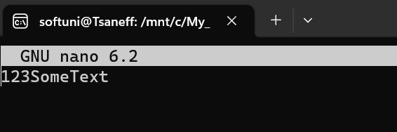

1. **Unmount the Windows drive:** 
   * When you are finished working with the Windows files, you should unmount the Windows drive using the following command:

